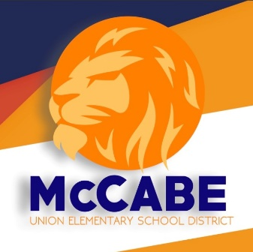
School Procedures and Protocols

The McCabe Union Elementary School District would like to remind parents of the following school procedures and protocols:

- Balloons are not permitted on campus due to:
  - Latex allergies for students and adults
  - Classroom, car line, and bus disruptions and distractions
  - Balloons released inside building with high ceilings and the possibility of triggering smoke detectors
  - The sound of a popped balloon may cause a panic

- Due to the importance of instructional time, student deliveries will not be made during class time.
  - Lunches may be left in the front office clearly labeled with the child’s name. Please remind your child that it is his/her responsibility to check the office for their lunch on the way to the cafeteria. Office staff will not interrupt class due to the high volume of lunches delivered in a day.
  - Lunches may be left ONLY for your child and not to be shared with other students due to possible allergies.
  - Flowers and gift deliveries will not be accepted at either office and will be returned with the delivery person.

- Birthday celebrations are not permitted on campus.
  - Classes are limited to three (3) class parties per school year: Christmas, Valentine’s Day, and End-of-Year
  - To comply with the MUESD Wellness Policy, parents may not bring cupcakes, cakes, cookies, food items, or balloons at any time for the purpose of celebrating a child’s birthday.
  - Parents and family members are welcome to eat lunch with their child in front of each school site. Adult MUST be listed as an emergency contact.
  - Parents are not permitted to eat with a child who is not their own.

